Wild Rivers Chiropractic

New Patient Information

Full Name _______________________________________________ Female Male Other _______________

Preferred Name ________________________________ Age _______ Date of birth ___________________________

Address ______________________________________ City ______________________ State____ Zip ___________

Home Phone __________________________________ Cell Phone ________________________________________

Email Address _________________________________ Name of Health Insurance ________________________

ID# _______________________ Group#_____________________ Relation to Insured: Self Spouse Child

Policy Holder DOB: _________________________ Policy Holder Address __________________________________

Emergency Contact ___________________________Relation __________________ Phone ________________________

How did you hear about us? _______________________________________________________________________

History of Present Illness

Reason for today’s visit: __________________________________________________________________________

How problem began ____________________________________________________ Date of onset ______________

Describe the pain _____________________________________ Is it getting worse? Yes No Constant Comes/goes

Does the pain radiate? Yes No If yes, please describe ______________________________________________

Does it interfere with your daily routine? Yes No Please explain ______________________________________

Have you had the same/similar symptoms before? Yes No If yes, date of prior condition ___________________
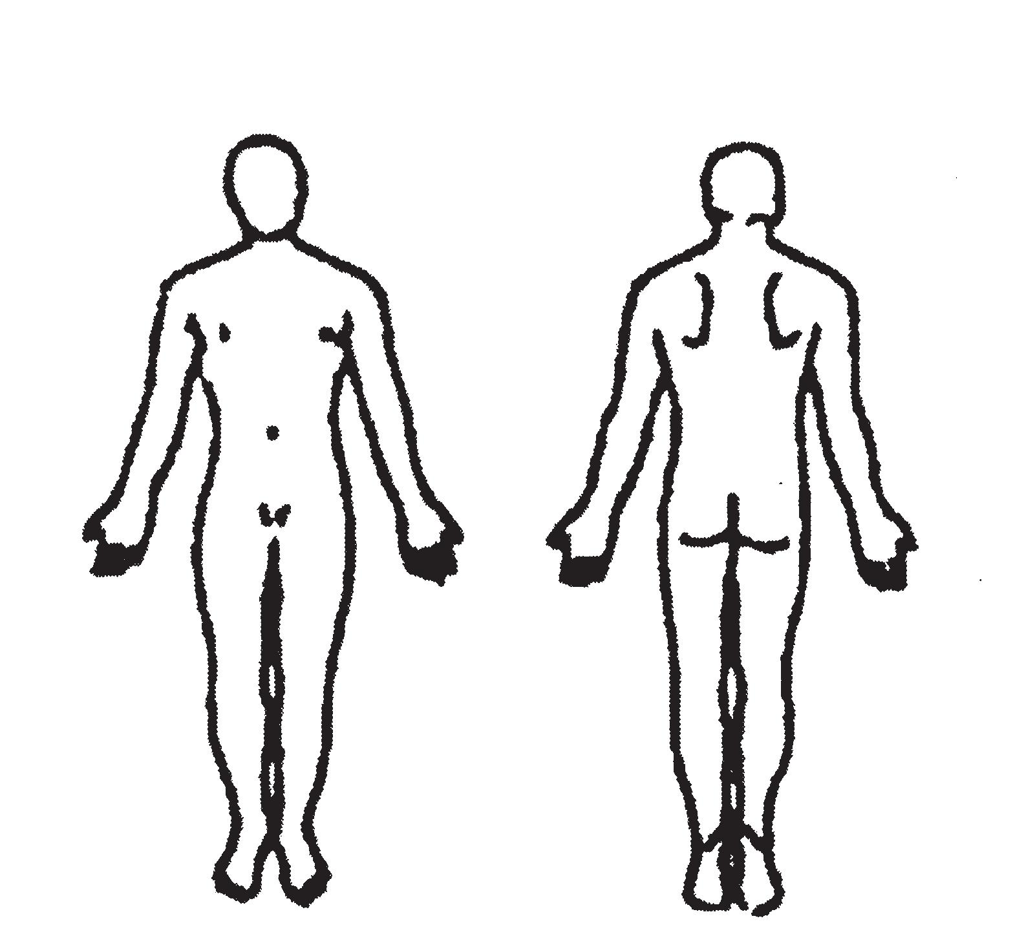
Other providers seen for this condition: _______________________________________________________________

Mark Areas of Pain on Figures Below
Have you had chiropractic care before? Yes No _______________

Family Physician ____________________________________________

May we forward our findings to your doctor? Yes No

Current Medications ________________________________________
__________________________________________________________

Allergies (Medicine, Food, Environment) ________________________
__________________________________________________________

Previous Trauma/Surgeries ____________________________________ __________________________________________________________

Do you have a PERSONAL or FAMILY history of: Cancer Diabetes Heart Disease Stroke

Other serious illnesses _____________________________________________________________________________

Check all symptoms that apply to you:

Headaches | Tingling/numbness in arms/hands |  | Chest Pain | Unexplained weight loss
Neck Pain/Stiffness | Tingling/numbness in legs/toes |  | Knee Pain | Fatigue
Back Pain/Stiffness | Loss of balance/dizziness |  | Hip Pain | Night Sweats
Shoulder Pain | Shortness of breath |  | Fever | Blood in Urine
Other _____________________________________________ |  |  | Night Pain | Pain unrelieved by rest

INSURANCE INFORMATION, CONSENT OF PROFESSIONAL SERVICES AND RELEASE OF INFORMATION

I understand and agree that health and accident insurance policies are an arrangement between an insurance carrier and myself. Furthermore, I understand that this office will prepare any necessary reports and forms to assist me in making collection from the insurance company and that any amount authorized to be paid directly to this office will be credited to my account on receipt. However, I clearly understand and agree that all services rendered to me are changed directly to me and that I am personally responsible for payment. I also understand if I suspend or terminate my care and treatment, any fees for professional services rendered to me will be immediately due and payable.

I hereby authorize Dr. DeSantis and their affiliated providers to administer treatment, physical examination, X-ray studies, laboratory procedures, chiropractic care, physical therapy, or any clinic services that they deem necessary in my case; I do hereby give my consent for the performance of conservative non-surgical treatment, including, but not limited to manipulation, physical therapy modalities, soft tissue massage and therapeutic exercises. I am aware there are possible risks and complications associated with these procedures, ranging from soreness to stroke. I understand there is no certainty that I will achieve benefits and acknowledge that no guarantee has been made regarding the outcome of these procedures. I am aware there are alternatives to these procedures, including medication and/or surgery. I further authorize them to disclose all or any part of my (patient’s) record to any person or corporation which is or may be liable under a contract to the clinic or to the patient or a family member or employer of the patient for all or part of the clinic’s charge, including, and not limited to hospital or medical services companies, insurance companies, workers compensation carriers, welfare funds, or the patient’s employer.

I understand that if an insurance company initially pays for my treatment and later requests reimbursement from Wild Rivers Chiropractic LLC for any reason, I will be responsible for payment of my entire outstanding balance.

We invite you to discuss any questions you might have with us. The best health services are based on a friendly mutually understood relationship.
Patient’s or Guardian’s Signature _________________________________________Date ______________________

CONSENT TO TREAT A MINOR

I (we) being the parent, guardian or custodian of the minor being _______________________________, age ______, do hereby authorize,

request & direct Wild Rivers Chiropractic LLC, it’s doctors and staff to perform examinations, diagnostic x-rays, laboratory tests, and any treatment that in their judgment, is deemed advisable or required.

It is the understanding of the undersigned that the physicians and their staff will have full authority from me as legal parent/guardian to continue with examinations, diagnostic tests, and treatments as will be needed while said minor shown above is under care in this office until legal age is attained.

As legal parent/guardian, I realize full responsibility for all charges and payments due.

Parent/Guardian or Custodian Signature _______________________________ Date ____________________

Witness __________________________________________________________

